**Group Project Part B (GP-B)**

**IKEA: Home Furnishings & Home Goods**

Bramma Sakthi Panneerkai Perumal (Z1938932)  
Hita Gurunath Kadam (Z1908140)  
Rahul Kumar Vellaturi (Z1937768)  
Sri Sai Surya Gutta (Z1937378)  
Vishnu Sai Teja Swarna (Z1975087)

Department of Operations Management and Information Systems

Northern Illinois University

OMIS 697 Digital Transformation Strategy

Prof. Brian Bender

October 17th, 2022

**IKEA – Overview**

IKEA has developed over the past 70 years from a tiny, family-owned business in Sweden to the largest home furnishings shop in the world. Digitalization has been called a disruptive development that challenges businesses, and whole industries. Regarding retail, omnichannel strategies, business models, multi-sided platforms, and the restructuring of retail outlets have all gained more attention from both the consumer and retailer viewpoints due to digitization. Studies show that integrating different digital technologies into retail, not only by turns based upon their usage and retailer’s objectives, but also by turns based upon their social presence and consumer convenience, and their use about shopping behavior at various stages of the customer's journey. Also, Retail was one of the industries which was most severely impacted by the global pandemic. Ikea hastened its digital transformation to meet consumer demand. Ikea created contactless Click & Collect services in collaboration with Google Cloud that lets customers order things using their smartphone and pick them up curbside. To assist customers in seeing how things will appear in their homes, Ikea also improved its 3D modeling and VR/AR capabilities. Despite that, around 70% of their sales happened through in-person store sales.

**Enhancing customer experience by designing a digital transformation strategy**

**Vision:**

At IKEA the next phase of digital transformation will be focused on customer experience.  The most prevalent complaint from customers regarding their experience at IKEA is the long queue at the checkouts. Our vision is that within the next three years, AI-monitored dashboards will be installed across the stores with these key features: scan and go, recommendations, visualization, and real-time queue monitoring (smart lane system) also customers are provided with smart devices inside the store to improve their experience. This intuitive, helpful innovation towards customer engagement will make the customers know they are valued, their needs are our first concern, and we care about them.

**Strategies:**

To ensure that we build and implement capabilities that focus on customer engagement through technology, and focus on customer, we have selected four key tactics.

* **Scan and go:** In this ‘scan & go’ system, shoppers can scan the products they want to purchase using a device. In this way, they are virtually bagging up items in the app as they go. Once they are ﬁnished, they go to a speciﬁed ‘scan & go’ only checkout where they can pick up their items by scanning their payment receipt.
* **Recommendations:** when the customer scans a product, based on the customer’s interest, new recommendations about products that are bought together will be given by an AI-powered app instead of going around and searching for them.
* **Visualization:** Customers can visualize their products in their homes to see how their masterpiece fits along with other furniture in AI Monitor and from the Ikea device.
* **Smart Lanes:** People counting sensors will be placed above each checkout counter. The number of customers being serviced, the number of customers waiting to be served, and the length of time they have been waiting are all counted. When paired with advanced algorithms and real-time store footfall data, this can be utilized to calculate forecast queue volume and issue alerts if it is about to exceed specified levels. This makes it feasible to respond to client demand as quickly as possible, keeping the checkout lines moving smoothly, cutting down on customer wait times, and enhancing their shopping experience.

**Front-end operation in the store:**

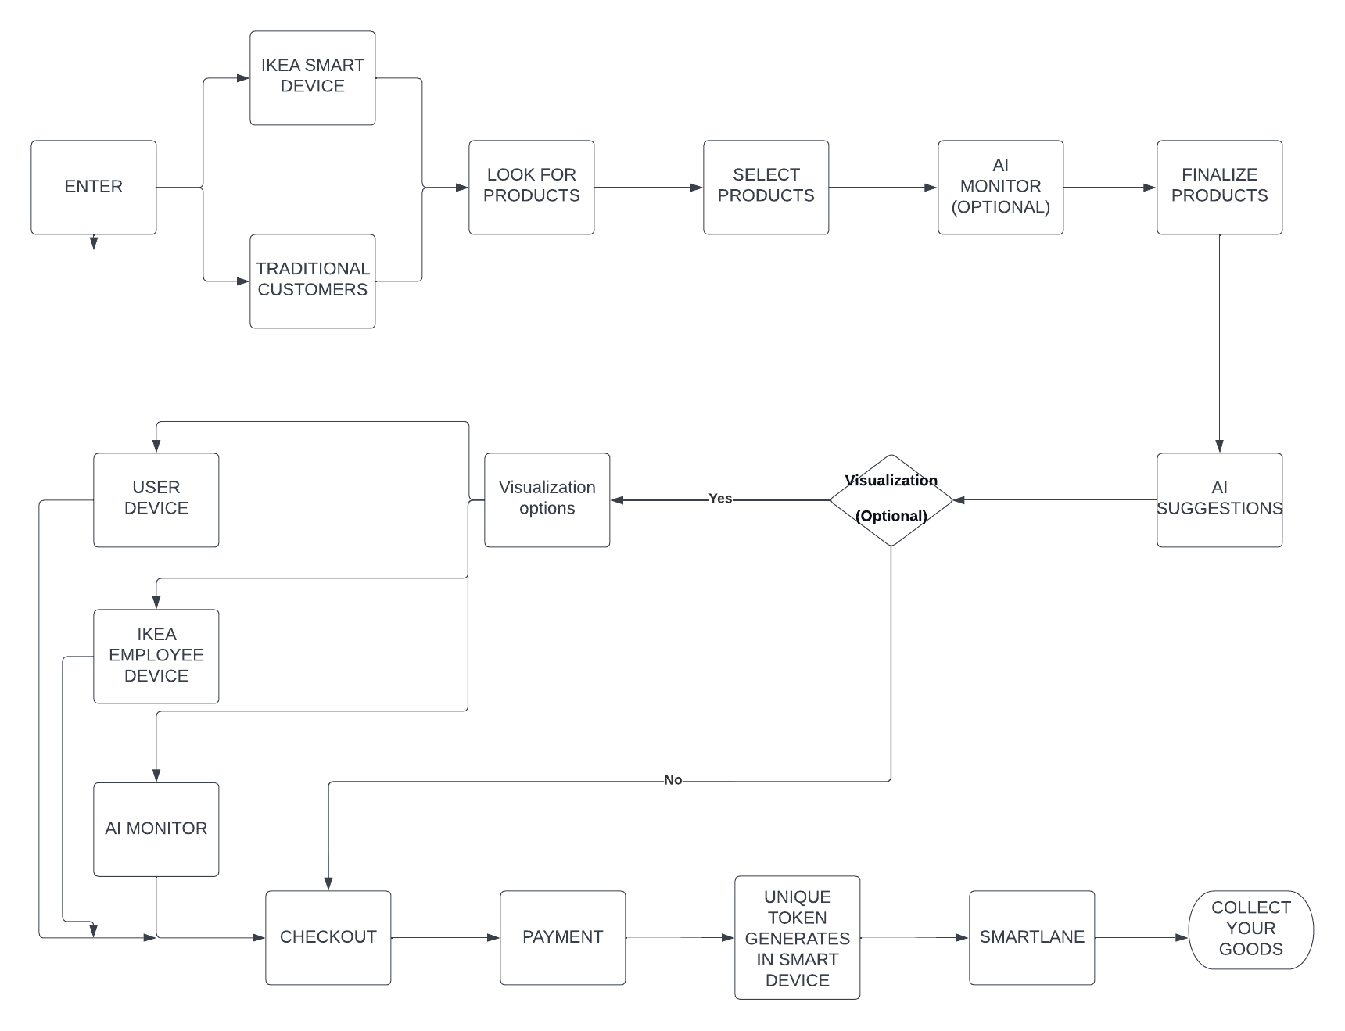

When the customer enters the IKEA store, customers have the option of taking smart devices and shopping themselves or getting assisted by employees who are not familiar with technology or physically handicapped, or for some other reasons. They can look at and select the products of their interest with help of the smart device. This smart device also has a scanner which is mounted to it through which customers can scan and check the products. This can be done by the AI monitor which is installed at some points inside the store. After making the changes they can finalize the products. After finalizing the products, they get suggestions for the products they have selected if they select a sofa, they get suggestions related to lamps, side tables near the sofa, etc. If they want, they can select the products. They can add this to the final checklist and visualize which is optional. If they wanted to visualize the products, they can make changes accordingly like the number of products, size, etc. If the customer has IKEA smart device or gets assistance from an IKEA employee or an AI monitor, they can proceed to checkout. They can make the payment after a smart token is displayed to the customer on the device upon his/her confirmation. They can exit the store through the smart lane and collect their products.

**Back-end operation in the store:**

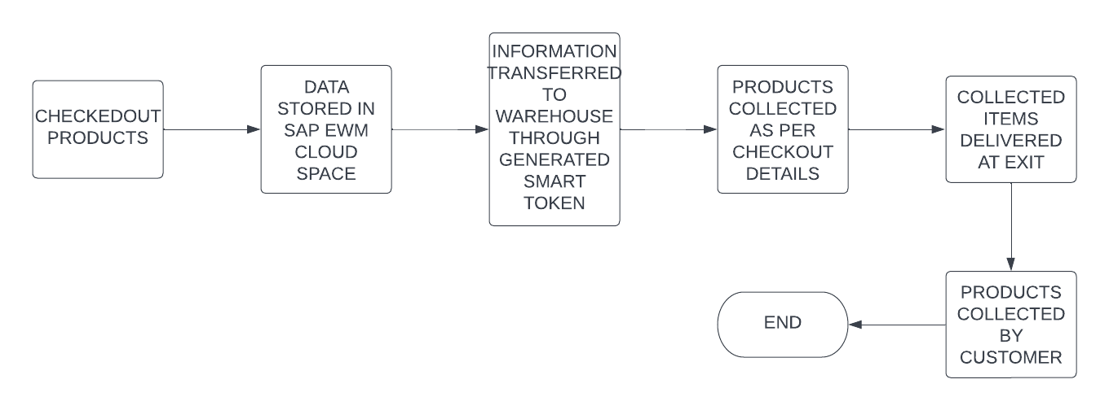

IKEA with their existing software technologies which are implemented to run their business end-to-end can optimize more by adding some additional packages that are implemented at a rapid pace with basic to advanced functions. This approach provides more capabilities for less cost. Since IKEA is a huge store with included warehouse, they can revamp their existing WMS system to SAP Extended WMS which is a cloud solution. So, once the customer gets a smart token before the payment confirming they are ready for the payment that will trigger the notification for the warehouse members at the backend and they can pick, pack, and load it. This advanced warehouse management system can be used using Enterprise Resource Planning (ERP) software which is SAP EWM (Extended Warehouse Management). With this modern, flexible WM system we can manage a high volume of goods and run agile operations with digitalized and accelerated warehouse processes. Can manage complex supply chain logistics and distribution processes with which the levels of visibility and control are high. This can be deployed into on-premises and cloud still being a comprehensive warehouse solution. As this is fully integrated the quality, production, and track-and-trace processes are available for optimal usage and enable direct control over warehouse automation equipment and robots.

**Impacts:**

Long wait times have been identified as the primary cause of customer unhappiness in the retail industry. The scan & go strategy will help customers to skip long checkout lines and cut down on their wait times as it speeds up the transactions and enhances customer satisfaction. It also reduces the dependency on check-out staff. The Smart Lane system tracks the movement of customers using advanced infrared technologies. The software then forecasts checkout demand up to an hour in advance. Additionally, by utilizing "scan & go" devices, manual receipts are eliminated as IKEA and their customers can store them digitally. Other benefits include saving IKEA money and enhancing its CSR by lessening the environmental effect. The "scan and go" method also has the potential to advance augmented reality and artificial intelligence by using the data gathered to encourage up-selling, which will increase the profit.

Customer can also visualize their product in a 3D view simply by entering the dimension or adding a picture of their house to visualize it. Placing AI monitors on the floors will help the shoppers to shop in a single place without walking throughout the store. This will also help the customers to identify the aisle of the product and their availability based on the store stock. As of now, IKEA warehouse employees will start fetching the products from the warehouse after the payment from the customer. Instead, products should be fetched from the warehouse once the buyer confirms the products in the smart device. In this way, products will be available when they approach the smart lane to make payments. Higher the waiting time to get a product, the higher the chance of losing a customer. Companies that prioritize their customers can outperform their rivals by 70%. By prioritizing the needs of the customer, implementing these features will greatly help Ikea to outperform its rivals.

As SAP Extended Warehouse Management is integrated into the S/4 HANA (High-Performance Analytic Appliance) platform, the built-in analytics engine of S/4 HANA may be utilized to create extensive analyses and reports of both live transaction data and warehouse activities in real-time. A wide range of users may access preconfigured reports and real-time dashboards that are adapted to their unique tasks. Accuracy and productivity are improved when decision-makers have unified access to crucial performance information in real-time and may base their decisions on the current state of the operations.

**Obstacles:**

* **Research & Development:** Researching new technologies and developing the App to incorporate various features along with its testing and development would account for a lot of time investment.

**Solution:** IKEA can consider incorporating Beta testing by assembling a few devices and monitors at stores in major metro cities and collecting feedback and response from customers for initial testing and improvements.

* **Employee Upskilling:** Existing employees need to be trained in the product before having the customers use it. Hiring animation experts to carry out the visualization process smoothly and efficiently would be essential.

**Solution:** IKEA could consider collaborating with startups engaged in animation and interior design as an outsource project and eventually develop the skills in-house.

* **Data Storage & Accessibility:** Incorporating every range of products along with their visualizations and accessible all the time to multiple customers could be a challenging thing at the start.

**Solution:** We could initially start with having all major products and their visualizations in the app. At least 1 item from each category is available for users to test. Slowly adding on items with each rolling patch.

* **Warehouse Limitations:** As the SAP EWM can only work on web-based devices there are a few challenges as this does not work with iOS, Android, and Desktops.

**Outcomes of Successful Implementation:**

* **Customer experience:** Owing to the ease of visualization and real-time interactive features, customers would experience setting up a virtual setup before choosing to buy items. This would enhance their experience and raise the levels of customer satisfaction.
* **Marketing:** With out-of-the-world experience, word-of-mouth marketing would be an exceptional outcome from a business point of view, which would lead to inviting more customers to the IKEA family and in turn lead to an increase in sales. IKEA would achieve the goal of reaching every house.
* **Reduction in customer wait time:** With the incorporation of features such as scan & go and smart lanes, the overall customer wait time would be reduced and the entire process time would be shortened.

**Negative Implications:**

* With complex customization requests from customers, the visualization setup would take longer than usual if many items and multiple requirements are mentioned by a user. This can be improved by testing and development.
* The device provided to the users after entering the store could be lost and never returned to the store before exiting. This can be controlled by enabling a lock on the device which will only allow the IKEA shopping app to be accessible on the device. Hence, it cannot be used by users for any other purpose.
* Customers' visits to different units/sections might be reduced since they can go through all items in the app itself. Customers looking for a look and feel will still visit the desired sections. Customers entering with a fixed list of shopping items would not wander in the store like others.

**References**

Morgan, B. (2019, Sep 24). *50 Stats That Prove The Value Of Customer Experience*. Retrieved from Forbes: <https://www.forbes.com/sites/blakemorgan/2019/09/24/50-stats-that-prove-the-value-of-customer-experience/?sh=3ff3a1124ef2>

<https://www.irisys.net/queue-management/resources/tesco-case-study>

<https://www.researchgate.net/publication/332550402_IKEA_Operations_Analysis>

<https://comparecamp.com/sap-ewm-pricing-pros-cons-features/>

<https://www.emerald.com/insight/content/doi/10.1108/IJRDM-12-2020-0510/full/html>

<https://www.sapusers.org/news/559/how-could-you-benefit-from-sap-extended-warehouse-management-ewm>

<https://prezi.com/p/ak0zle9e2xj_/ikea-business-model/>

<https://businesschronicler.com/swot/ikea-swot-analysis/>